Creating an Azure App Service
Instructor Walkthrough + Practical Demo Steps
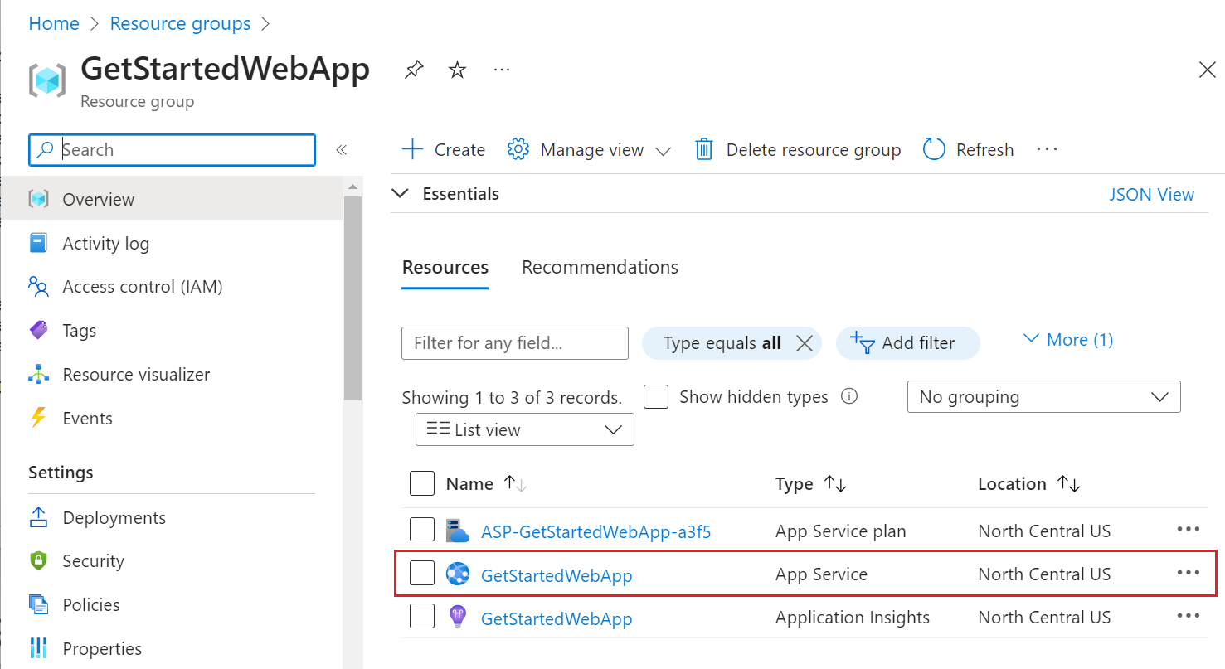
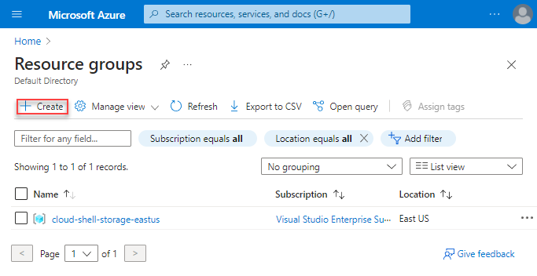
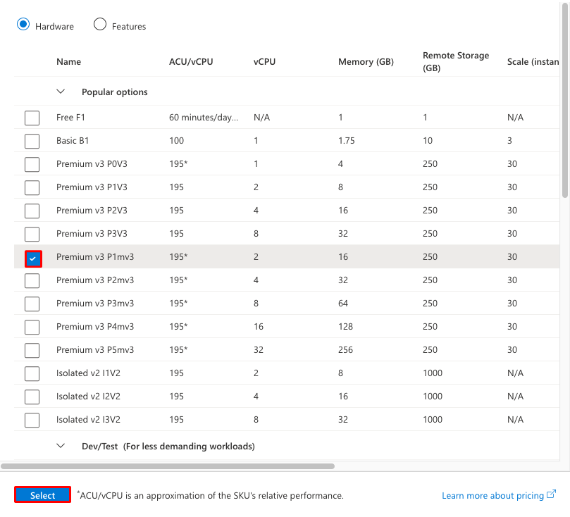
Azure App Service is a fully managed Platform-as-a-Service (PaaS) used to host web applications, REST APIs, and mobile backends. It removes infrastructure management (IIS setup, OS patching, scaling, load balancing) so developers focus only on code.
Below is the complete process to create an App Service using the Azure Portal.

1. Log in to the Azure Portal
- Open your browser.
- Navigate to https://portal.azure.com
- Sign in with your Azure credentials.

2. Navigate to “Create a Resource”
- From the left-hand navigation, select Create a resource.
- In the search bar, type App Service.
- Choose App Service from the results.
- Click Create.

3. Fill in App Service Basic Details
On the Basics tab, complete these fields:
3.1 Subscription
Choose the Azure subscription where the app will be billed.
3.2 Resource Group
Choose an existing Resource Group or create a new one.
Example:
- Name: RG-AppServices-Demo
3.3 Instance Details
- Name: This becomes your site name and DNS.
Example: mywebapi-demo
URL will be: https://mywebapi-demo.azurewebsites.net
- Publish: Choose one:
  - Code (for .NET, Node.js, Java, Python apps)
  - Docker Container (if deploying containerized apps)
- Runtime Stack: Select your tech stack
Example: .NET 8 (LTS)
- Region: Choose a region close to your users
Example: Central India, South India, East US

4. Configure the Hosting Plan (App Service Plan)
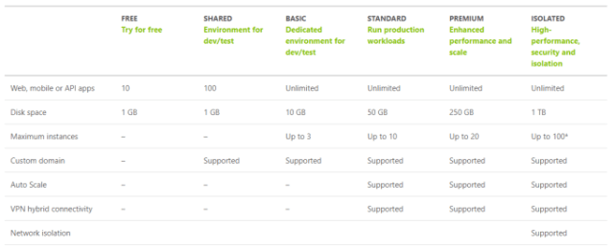

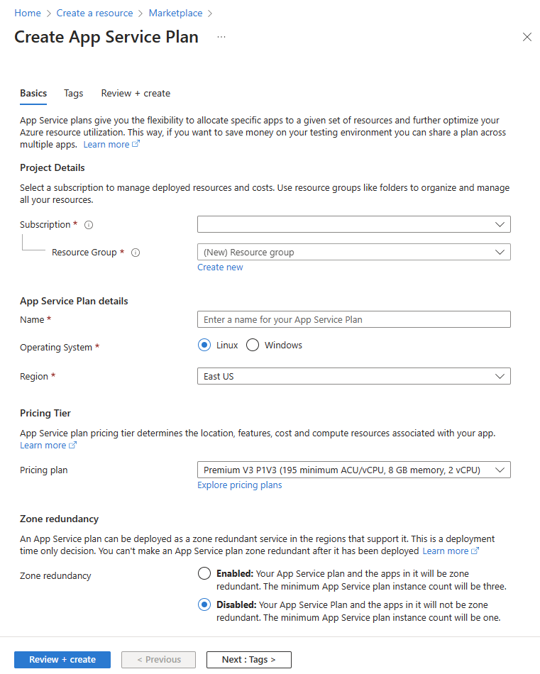
4
What is an App Service Plan?
It defines:
- Pricing tier
- Compute power (CPU, RAM)
- Autoscaling capability
Steps:
- Click Create new under App Service Plan.
- Enter plan name:
Example: ASP-Demo-Plan
- Select Pricing tier:
  - Free (F1) – For learning/testing, limited performance
  - Basic / B1 – Production entry level
  - Standard / S1 – Autoscaling, suitable for real workloads
  - Premium (P1v3) – High performance enterprise workloads
For demo environments, B1 or F1 is fine.

5. Configure Other Tabs (Optional but Useful)
5.1 Deployment
You can enable:
- GitHub Actions
- Azure DevOps
- Bitbucket
- Local Git
Choose Enable Continuous Deployment (Optional) if using CI/CD.
5.2 Networking
- Enable VNet Integration if your app needs private resources.
5.3 Monitoring
- Application Insights (recommended)
- Choose Enable
- Select Region (should match App Service region)
5.4 Tags
Add metadata for cost management.
Example:
- Environment: Dev
- Owner: San San

6. Review + Create
- Click Review + Create.
- Azure will validate your configuration.
- Click Create.
Deployment takes 20–40 seconds.

7. Open the App Service
Once deployed:
- Click Go to Resource.
- On the overview page, you will see:
  - Default app URL
  - App Service Plan
  - Configuration options
  - Deployment center
Click the URL in the overview panel to confirm the app is running (you will see the default Azure page).

8. (Optional) Deploy Your ASP.NET Core API
You can deploy using:
- Visual Studio Publish
- Azure DevOps CI/CD
- ZIP deploy
- FTP
- GitHub Actions
- Docker Container Deployment
If you want, I can guide you step-by-step to deploy your ASP.NET Core API using Visual Studio after this.

Summary of Key Concepts
Component | Purpose
App Service | The web hosting environment
App Service Plan | Defines compute, region, pricing
Runtime Stack | Framework for your app (.NET, Node, etc.)
Region | Physical datacenter location
Application Insights | Monitoring and logging

